**Marcelino 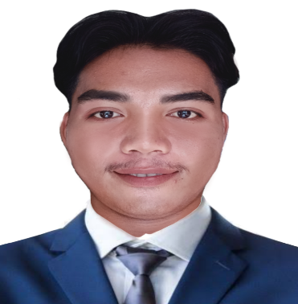R. De Gracia**

**Address**: Manggahan Bagong Pook General Trias Cavite.

**Mobile No:** 09384677716

**Email:** marcelinodegracia17@gmail.com

**CAREER OBJECTIVE**

Self-motivated student with the ability to create new ideas to foster the goals of a company. Looking to gain an internship position to utilize my abilities and skills in ensuring efficiency.

**QUALIFICATION**



* Good listening skills and ability to take detailed instruction.
* Honest and dedicated to a work given at hand.

**PERSONAL INFORMATION**



|  |  |
| --- | --- |
| **Date of Birth** | : November 17 1999 |
| **Place of Birth** | : San Loreto Del Sur |
| **Age** | : 21 |
| **Civil Status** | : Single |
| **Nickname** | : Marce |
| **Gender** | : Male |
| **Height** | : 168 |
| **Weight** | : 60 kl. |
| **Mother** | : Hermelyn De Gracia |
| **Occupation** | : Deceased |
| **Father** | : Marcelino De Gracia |
| **Occupation** | : Deceased |
| **Religion** | : Born Again |

**EDUCATIONAL ATTAINMENT**



**Tertiary Education**

School: Cavite State University Trece Martires City Campus

Degree: Bachelor of Science in Information Technology

Address: Barangay Gregorio 4109 Trece Martires City Cavite

School Year: 2019-2022

**Secondary Education**

Senior High School  
School: Asian Institute of Science and Technology   
School Year: 2016-2018  
Address: Emilio Aguinaldo Highway, Dasmariñas Cavite

Junior High School

School: Gov. Ferrer Memorial National High School – Biclatan Annex

Address: Biclatan Gen. Trias, Cavite

School Year: 2012-2016

**Primary Education**

School: Gen. Aloña Memorial Elementary School (GAMES)  
Address: Biclatan Gen. Trias, Cavite

School Year: 2006-2012

**SKILLS**

* Knowledge in Microsoft Office Applications (Word, PowerPoint, Excel, Access)
* Knowledge in Adobe Photoshop (Image Editing, Graphic Designs)
* Knowledge in HTML/CSS
* Knowledge in written and oral communication, both in Filipino and English
* Knowledge in Canva and Video Editing

**WORKEXPERIENCE**

* **Jollibee**

**Service Crew**

WalterMart Manggahan Gen. Trias, Cavite

January 10 2022 to Present

* **Voyager Internet Café Encoder**

**Customer Service**

Lotus Mall, Nueno Ave., Imus, Cavite

March 07 2018 to March 18 2018

**CHARACTER REFERENCES**



* Joemel E. Pulido  
  Barangay Chairman   
  Tejeros Convention Rosario Cavite
* Cesalyn Panuncio

Dasmarinas Cavite

* Marjorie Barabat

Carmona Cavite